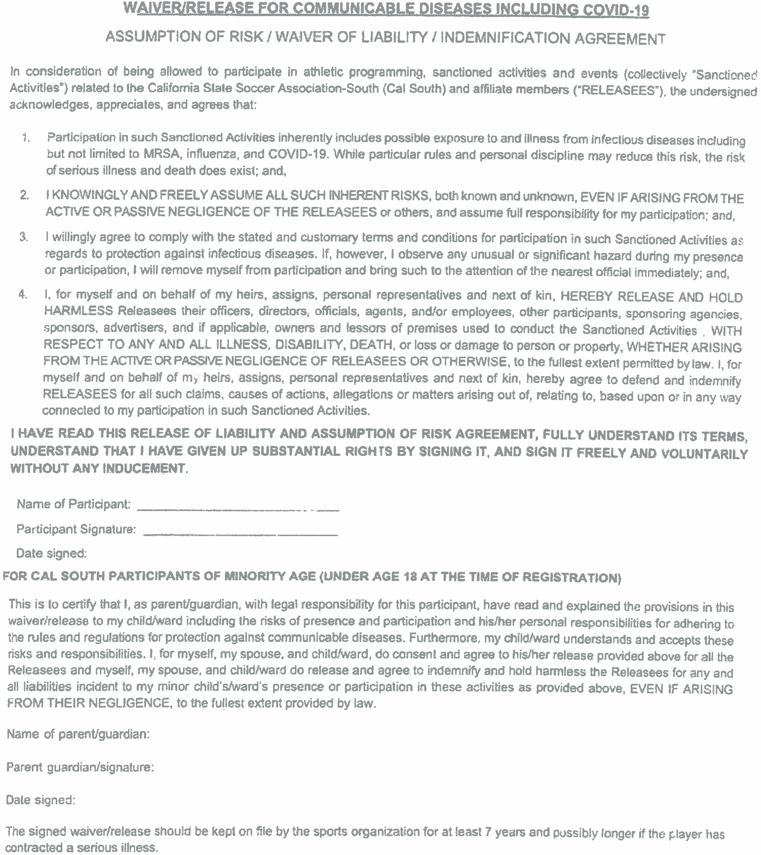

Concussion Policy:
Any player showing signs or symptoms characteristic with concussion will be removed
from participation/competition. If an athlete who is 17 years of age or younger has
been removed from athletic activity due to a suspected concussion, the youth sports
organization shall notify a parent or guardian of that athlete of the time and date of the
injury, the symptoms observed, and any treatment provided to that athlete for the
injury.
The player will not be allowed to return to play until he/she has a full unconditional medical
clearance from a licensed health provider or physician who is trained in the evaluation
and management of concussions and is acting within the scope of his or her practice.
The clearance must be on the physician’s letterhead and include his/hers wet and/or
original signature and display the address of the office location. It is important to note
that conditional clearances will NOT be accepted.
If the licensed health care provider determines that the athlete sustained a concussion
or other head injury, the athlete shall also complete a graduated return-to-play
protocol of no less than seven days in duration under the supervision of a licensed
health care provider.

